INTRODUCTION
Palm Cooling Delays Fatigue During ………
Young sub Kwon¹⁾ ᛫ Robert A. Robergs^{1,2)} ᛫ Len R. Kravitz¹⁾ ᛫ Burke A. Gurney³⁾
1) Department of Health, Exercise & Sports Sciences, University of New Mexico, New Mexico, U.S.A.;
2) School of Biomedical and Health Science, University of Western Sydney, Sydney, Australia.
3) Department of Orthopaedics and Rehabilitation, University of New Mexico School of Medicine, New Mexico, U.S.A.

ABSTRACT
Local cooling can induce an ergogenic effect during short term intense exercise. One proposed method of personal cooling involves.. …….. PURPOSE: In this study we hypothesized that ……... METHODS: Sixteen male subjects (mean±SD, age = 26±6 yr, height = 178±7 cm, body mass = 81.5±11.3kg, 1RM Bench press = 123.5±12.6 kg, weight training experience = 10±6 yr) performed 4 sets of 85% 1RM bench press exercise to fatigue, with 3 min rest intervals. Exercise trials were performed in counterbalanced order on three days, separated by at least 3 days; thermoneutral (TN), palm heating (PH), and palm cooling (PC). Heating and cooling were applied by …………. This device heats or cools the palm while negative pressure (-35 to -45 mmHg) is applied around the hand. RESULTS: Total exercise volume (kg) during the 4 PC sets (2480±636) was significantly higher than during TN (1972±632) and PH (2156±668) sets, (p<0.01). The RMS of the surface EMG with PC exercise was higher (p<0.01), esophageal temperature (p< 0.05) and RPE (p<0.05) were lower during PC compared to TN and PH. CONCLUSION: Palm cooling from 35 to 20ºC temporarily over-rides fatigue mechanism(s) during intense intermittent resistance exercise. The mechanism(s) for this ergogenic function ………….

Key Words: esophageal temperature, EMG, exercise training, resistance exercise
Traditionally local cooling has been used in a rehabilitation situation or between bouts of intense exercise to reduce swelling and inflammation (Foster et al., 2014; Oei et al., 2005). However, prior research of the effects of local cooling on muscle function during exercise has produced inconsistent findings, which are ……..

METHODS
Subjects.
Sixteen healthy male subjects volunteered for this study. The subjects had participated in regular, intense weight training for a minimum of five years, and their ratio of weight pressed to body weight during bench press was more than 80% of age-based upper body strength.

Power Analysis.
The number of subjects was based on a power analysis using data from Verducci. Without cooling, the average total work was 52795±7424 joules (average±SD) while with cooling the average total work was 60233±8223 joules. The statistical significance level was set at α=.05, 1-β=.08 for all tests.

Overall protocol.
There were a total of four experimental days. During the first testing day, subjects were familiarized with the testing protocol. They performed a 1RM supine bench press test, and after 5 min of rest they completed one endurance set to fatigue at 85% of 1RM. Before the first 1RM test, each subject gained familiarity with the barbell bench press exercise by performing it under the guidance of the primary investigator.

Procedures during each Testing Day

Treatment conditions.
Hand cooling and heating with negative pressure were induced by using two Rapid Thermal Exchanger (RTX) hand cooling devices, one on each hand (RTX Heating/Cooling Model # 200962-006B, AVAcore Inc., Palo Alto, CA). The control trials consisted of placing the hand in the RTX with negative pressure but without application of cold or hot water.

Exercise Procedures
Day 1: 1RM and 1 85% of 1RM endurance test
On a testing day, participants were asked if they had any soreness or injury to their shoulders, triceps, and chest and if they had refrained from caffeine and vigorous exercise in the previous 24 hours. If subjects complied to these requirements, they did their usual warm-up and then positioned themselves under the bar with their usual grip. All subjects were given 3 minutes of rest between sets. After the 1RM test, subjects had a 5-minute rest period and then tried to lift as many repetitions as possible using 85% of 1RM. A 1RM test was performed before each fatigue test because the EMG signal from the muscle surface varies from one location to another, and thus the absolute EMG signal cannot be compared between separate days.
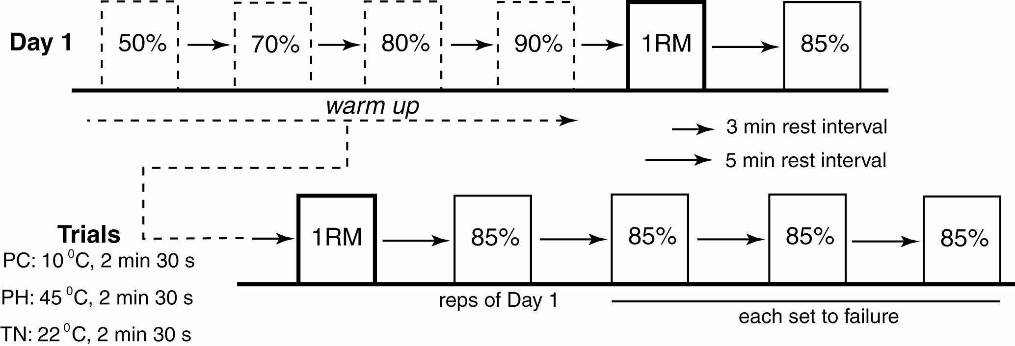
FIGURE 1-Protocols for Warm-up, 1RM test, and 85% of 1RM sets of bench press exercise in thermoneutral (TN), palm cooling (PC), and palm heating (PH) conditions. Exercise intensity (% of 1RM) is denoted in each column representing each set. After 1RM and the 1st set, the exercise in three sets of every protocol continued until the subjects failed to complete a lift.

Days 2, 3, and 4: 1 RM and four 85 % 1RM endurance tests
The participants were required to perform a warm-up of 10 repetitions at 50% of 1RM, 5 repetitions at 70% of 1RM, 3 repetitions at 80%, and 1 repetition at 90% of 1RM, stretching chest, shoulder and triceps between sets. After 5 minutes they lifted their 1RM. After another five min of rest, four sets with weights of 85% of 1RM were performed until fatigue.

Specific Measurements

Rating of Perceived Exertion (RPE).
Im-mediately after each endurance set, participants were asked to answer the question “How hard was your workout?” to find their perceived exertion following the completion of each set based on a modified 10-point RPE scale (0: Rest and 10: Maximal).

Esophageal and Palm Temperatures.
Uncovered skin thermistors (Grant Instruments Ltd, Cambridge, UK) were attached to the right palm with elastic straps during the TN condition. During PC and PH conditions, palm temperature was measured by the RTX (by thermocouples embedded in the hand cone). In each condition, palm temperatures (Tpa) were recorded during 2.5 min of the rest periods.

Statistical analyses.
All statistical computations were performed using STATISTICA version 7.1 software (StatSoft, Inc., Tulsa, OK). A two-way, repeated-measures ANOVA test was used to quantify the differences in…….. Exercise volumes (Kg, Sets×Repetitions× Weight) among conditions were compared using …... When a significant F-ratio was obtained, a Tukey’s Honestly Significant Difference test was performed. Statis-tical significance was accepted at p<0.05. All data are presented as the mean ± SD.

RESULTS
Subject Characteristics and Environmental Variables.
The descriptive characteristics of the sixteen healthy male subjects who participated in the study are as follows; age=26±6 years; height =178±7cm; weight=81.5±11.3; body fat=10.3±5.4; 1RM=123.5±12.6kg; the ratio of weight pressed to body weight=1.5±0.2; weight-training experience= 10±6years

Mean palm skin temperature during rest periods among the three conditions.
There were significant differences in palm skin temperature during rest periods between conditions (p<0.01), Figure 2. There were no significant differences within a condition between the three rest periods.

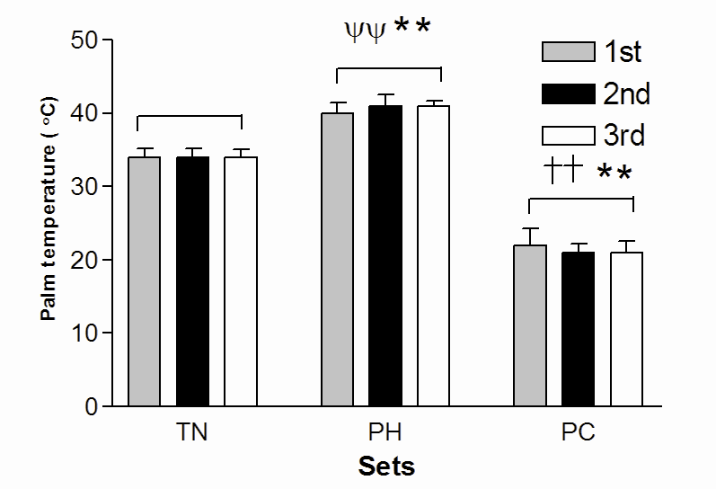
FIGURE 2-Mean palm skin temperature during the four 85% of 1RM sets of bench press exercise. Data were obtained during rest periods of thermoneutral (TN), palm cooling (PC), and palm heating (PH) conditions. Each value represents the mean palm skin temperature (n=16). Error bars indicate SD. Asterisk (*) indicates PC vs. PH conditions (*p<0.05, **p<0.01). Symbol (†) indicates PC vs. TN conditions (†p<0.01, ††p<0.01). Symbol (ψ) indicates PH vs. TN conditions (ψ p<0.05, ψ ψ p<0.01).

Exercise volume.
There were significant differences in exercise volume between the TN, PH, and PC conditions. Mean exercise volume (kg) of PC (2479±636) was significantly higher than both PH (2156±668), p<0.01 and TN (1972±632), p<0.01. There was no significant difference between TN and PH in exercise volume (p=.08), Figure 4A.

Core temperature in 6 subjects.
Changes in Tes were significantly different among conditions, p<0.01. PC condition (36.97±0.08) had significantly lower mean Tes than both PH (37.02±0.10), p<0.01 and TN (36.99±0.08), p<0.05 conditions. There also was a significant time effect between baseline, rest periods, and 1min post-exercise after the 4th set, p<0.01. The condition × set interaction effect was significant (p<0.01), Figure 5.

TABLE 1. The mean difference (%) in RMS, MF, and MDF during eccentric and concentric contractions during the four 85% of 1RM sets of bench press test during thermoneutral (TN), palm cooling (PC), and palm heating (PH) conditions, (n=16).
Muscle | EMG Variable (%) | Contraction | Change (%) |  |  | P Value
Muscle | EMG Variable (%) | Contraction | TN | PH | PC | P Value
The Pectoralis Major | RMS | ECC | 47±21 | 40±20 | 42±19 | .58
The Pectoralis Major | RMS | CON | 45±17 | 38±18 | 44±19 | .49
The Pectoralis Major | MF | ECC | 23±15 | 21±17 | 18±19 | .55
The Pectoralis Major | MF | CON | 28±13 | 23±15 | 26±13 | .43
The Pectoralis Major | MDF | ECC | 25±11 | 20±10 | 27±12 | .12
The Pectoralis Major | MDF | CON | 23±9 | 20±22 | 26±13 | .58
The Lateral  Head of Triceps | RMS | ECC | 12±20 | 19±14 | 40±18**†† | 0.01
The Lateral  Head of Triceps | RMS | CON | 29±29 | 37±32 | 53±30**†† | 0.01
The Lateral  Head of Triceps | MF | ECC | 10±11 | 19±19 | 18±10 | .20
The Lateral  Head of Triceps | MF | CON | 18±10 | 17±12 | 22±10 | .25
The Lateral  Head of Triceps | MDF | ECC | 14±11 | 21±15 | 20±10 | .31
The Lateral  Head of Triceps | MDF | CON | 22±14 | 19±12 | 26±13 | .21
The Anterior  Deltoid | RMS | ECC | 23±17 | 19±16 | 32±15 | 8.65
The Anterior  Deltoid | RMS | CON | 28±24 | 17±18 | 38±44 | 0.20
The Anterior  Deltoid | MF | ECC | 10±12 | 12±13 | 13±13 | 0.74
The Anterior  Deltoid | MF | CON | 16±9 | 14±10 | 21±10 | 0.06
The Anterior  Deltoid | MDF | ECC | 8±14 | 10±18 | 15±16 | 0.41
The Anterior  Deltoid | MDF | CON | 18±12 | 17±12 | 24±9 | 0.10
The Long  Head of Triceps | RMS | ECC | 31±26 | 31±19 | 36±25 | 0.65
The Long  Head of Triceps | RMS | CON | 24±23 | 29±26 | 20±14 | 0.45
The Long  Head of Triceps | MF | ECC | 14±10 | 13±8 | 15±7 | 0.86
The Long  Head of Triceps | MF | CON | 8±21 | 12±13 | 13±9 | 0.69
The Long  Head of Triceps | MDF | ECC | 16±7 | 18±8 | 19±9 | 0.64
The Long  Head of Triceps | MDF | CON | 15±19 | 18±16 | 16±12 | 0.84
Data are presented as mean±SD.
RMS, root mean square; MF, Mean Frequency; MDF, Median Frequency; ECC, Eccentric; CON, concentric; TN, thermoneutral; PH, palm heating; PC, palm cooling
Asterisk (*) indicates PC vs. PH conditions (*, p< 0.05, **, p< 0.01). Symbol (†) indicates PC vs. TN conditions (†, p<0.01, ††, p<0.01). Symbol (ψ) indicates PH vs. TN conditions (ψ, p<0.05, ψψ, p<0.01).
Rating of perceived exertion (RPE).
Changes in RPE were significantly different among conditions, p<0.05. The average RPE during PC (6.7±0.8) was significantly lower than during PH (7.0±1.1), (p<0.05).

Heart rate.
Changes in HR were significantly different among the conditions, p<0.05. The average HR (beats∙min⁻¹) during TN trials (108±26) was lower than during PH trials (112±26), p<0.05. There were no differences in HR between TN and PC (108±28) and between PH and PC trials, p=0.07, and HR was different from baseline during exercise and rest periods, p<0.01, Figure 6. The interaction effect also was significant, p<0.01. During the 2nd set HR during PC (141±19) was significantly higher than during TN (135±18), p<0.05. During the rest period between the 2nd and 3rd sets, HR during PH (88±21) was significantly higher than during TN (86±21), p<0.01, and PC (83±20), p<0.01. During the rest period between the 3rd and 4th sets, HR during PH (91±21) was significantly higher than PC (86±21), p<0.01. During 1 min post-exercise, HR during PH (100±20) was significantly higher than PC (94±21), p<0.01 and TN (95±21), p<0.05.

EMG.
There were significant differences in EMG values during both eccentric and concentric movements only in the lateral head of the triceps (Table 1).

DISCUSSION
To our knowledge, this is the first study to assess the impact of mild palm cooling and heating on fatigue during high intensity, multi-set bench press exercise. The remarkable finding of this study was ……...

Localized Muscle Cooling.
Our finding that palm cooling increases weight lifted during resis-tance exercise is similar to a previous study which used ice application (cryotherapy) between weight-pulling sets. This researcher found that ……

Central Blood Volume Cooling.
Our findings that palm cooling with negative pressure during rest periods between sets lowered esophageal temper-ature during exercise is similar to the findings of Grahn et al., where heat extraction from the palm improved aerobic endurance(Ward et al., 2003).. Certainly, there are differences in exercise mode between the present study and that of Grahn et al.

The EMG response.
Fatigue in a muscle is reflected by specific changes in the EMG recording in the time (RMS) or frequency (MF and MDF) domains (Wang et al., 2008; Igarashi et al., 2004). An increase in RMS might reflect greater total muscle fiber recruitment for a fixed submaximal external force (Jensen & Friedmann, 2002; Friedmann et al., 2001).

CONCLUSION
Disclosure of funding for this work: AVAcore Inc. lent the RTX devices used in this study, however this study was performed as part of the first author’s dissertation project without supple-mental funding. The results of the present study do not constitute endorsement by KINESIOLOGY.

REFERENCES
Edgerton V. R., Wolf S. L., Levendowski D. J., & Roy R. R. (1996). TTheoretical basis for patterning EMG amplitudes to assess muscle dysfunction. Medicine and Science in Sports and Exercise, 28(6): 744-751.
Henry, S. M., & Westervelt, K. C. (2005). The use of real-time ultrasound feedback in teaching abdominal hollowing exercises to healthy subjects. The Journal Of Orth-opaedic And Sports Physical Therapy, 35(6): 338-345.
Hides, J. A., Stanton, W. R., McMahon, S., Sims, K. & Richardson, C. A. (2008). Effect of stabilization training on multifidus muscle cross-sectional area among young elite cricketers with low back pain. The Journal Of Orthopaedic And Sports Phy-sical Therapy, 38(3). 101-108.
Milburn, P. D. (1982). Summation of segmental velocities in the golf swing. Medicine and Science in Sports and Exercise, 14(1), 60-64.
Panjabi, M. (1992). The stabilizing system of the spine. Part II. Neutral zone and instability hypothesis. Journal of Spinal Disorders, 5(4):390-397.
Pate R. R., Pratt M, Blair S. N., Haskell W. L., Macera C. A., Bouchard C,. Buchner D., Ettinger W., Heath G. W., King A. C.. (1995). Physical activity and public health. A recommendation from the Centers for Disease Control and Prevention and the American College of Sports Medicine. Journal of the American Medical Associa-tion, 273(5): 402-407.
Richardson, C. A., Jull, G. A. (1995). Muscle control-Pain control. What exercises would you prescribe? Manual Therapy, 1(1): 2-10.
Richardson, C. A., Jull, G. A., Hodges, P. W., & Hides, J. A. (1999). Therapeutic exercise for the spinal segmental stabilization in low back pain: scientific basis and clinical approach. Churchill Livingstone, Edinburgh.
Stokes, M., Rankin, G., & Newham, D. J. (2005). Ultrasound imaging of lumbar multifidus muscle: normal referance ranges for measurements and practical guidance on the technique. Manual Therapy. 10(2): 116-126.
Teyhen, D. S., Miltenberger, C. E., Deiters, H. M., Del Toro, Y. M., Pulliam, J. N., Childs, J. D., Boyles, R. E.. & Flynn, T. W. (2005). The use of ultrasound imaging of the abdominal drawing in maneuver in subjects with low back pain. Journal of Orthopaedic and Sports Physical Therapy, 35(6): 346-355.
Theriault G, & Lachance P. (1998). Golf Injuries: an overview. Sports Medicine, 26(1): 43-57
Sell T. C., Tsai Y. S., Smoliga J. M., Myers J. B., & Lephart S. M. (2007). Strenght, Flexibility, and Balance Chracteristics of Highly Proficient Golefers. Journal of Strength and Conditioning Research, 21(4): 1166-1171.

